Internal Guide — System Changes for UAE MPCI Advance Filing
e-Service and B/L Management in Portal

1. Purpose & Background
This guide explains the system changes made to support the UAE MPCI (Maritime Pre-load Cargo Information) filing requirement operated by NAIC. MPCI requires Bill of Lading data to be submitted before loading at the last foreign loading port for all containerized cargo bound for, transiting, transshipping, or remaining on board (FROB) at UAE ports.
Mandatory filing from 30 June 2026. The grace period (originally 31 March 2026) has been extended to 30 June 2026. During the grace period all filings return “Assessment Complete / ACT” with no DNL or penalty; from the mandatory date, missing or late filings can trigger DNL (Do Not Load) and penalties.
Filing basis: Deadlines are based on loading at the last foreign port (pre-load), not on arrival in the UAE. Master B/L: 6 hours pre-load; Direct B/L and lowest-level House B/L: 24 hours pre-load.
To capture the data NAIC requires, two systems were updated. This guide covers the e-Service first, then the Internal B/L Management portal.

New mandatory MPCI fields (summary)
Field | Where | Rule
Cargo Type = Consol | e-Service | Selecting Consol (House B/L) makes the MPCI Code field appear on the B/L entry screen.
Consignee MPCI Code | e-Service & Portal | Mandatory when CONSOL (House B/L). Forwarder’s UAE MPCI Party ID.
Consignee Nation | e-Service & Portal | Mandatory.
Consignee City Name | e-Service & Portal | Mandatory.
Notify Nation / City Name | e-Service & Portal | Mandatory.
HS Code | e-Service & Portal | Min. 6 digits. e-Service: one value per B/L. Portal: per-container entry via Tab 8.
Same mandatory fields apply in both systems; the entry screens differ as shown below.

2. e-Service (Customer Portal)
When entering an SR / B/L for UAE-bound shipments in e-Service, the MPCI Code (CONSOL only), Nation and City Name must be provided before the B/L can be submitted.

2.1 Cargo Type = Consol triggers the MPCI Code field
On the Basic Info. screen, the MPCI Code field appears only when the shipper sets Cargo Type to “Consol (House B/L)”. Because the shipper must declare the House B/L to MPCI directly, the forwarder’s MPCI-registered code must be collected and entered.
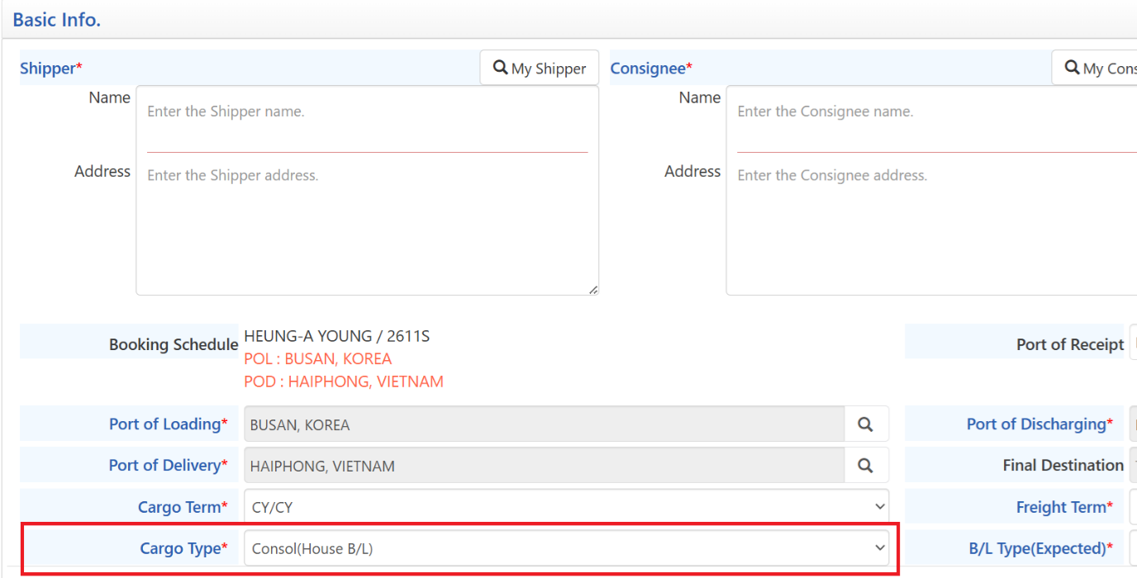
e-Service – Basic Info: setting Cargo Type to “Consol (House B/L)” enables the MPCI Code field.
Forwarders obtain/register their MPCI code at the NAIC portal: https://naic.icp.gov.ae/portal/registration/landing

2.2 Mandatory fields on the AFR / CCAM Info screen
- Consignee: Nation, City Name and MPCI Code are mandatory (red boxes below).
- Notify: Nation and City Name are mandatory.
- MPCI Code: required only for CONSOL (House B/L) shipments; this is the forwarder’s UAE MPCI Party ID.
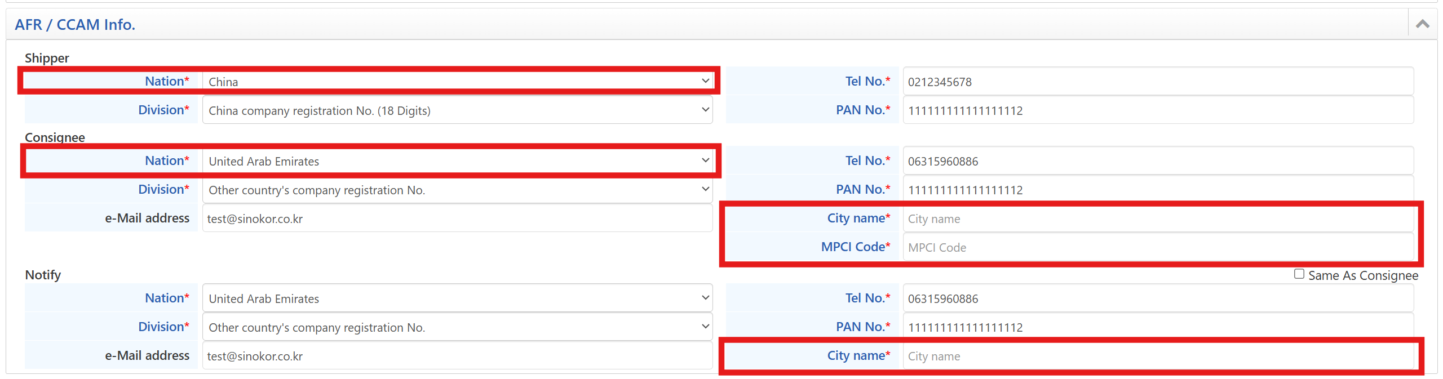
e-Service – AFR/CCAM Info: Consignee/Notify Nation, City name and MPCI Code are mandatory.

2.3 HS Code (minimum 6 digits)
For MPCI filing, a minimum 6-digit HS Code must also be entered on the B/L. In e-Service, one HS Code value is entered per B/L.
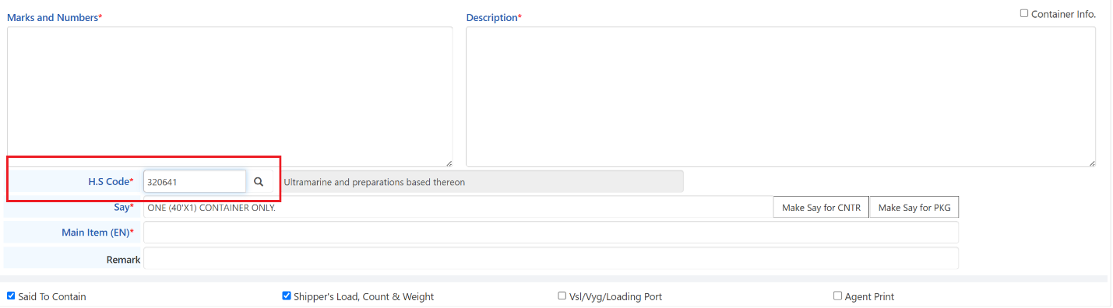
e-Service – H.S Code field (e.g. 320641): a minimum 6-digit HS Code is required for MPCI filing.

2.4 Missing-input warning
If the B/L is submitted without the required City Name or MPCI Code, an Error List is displayed listing each missing field.
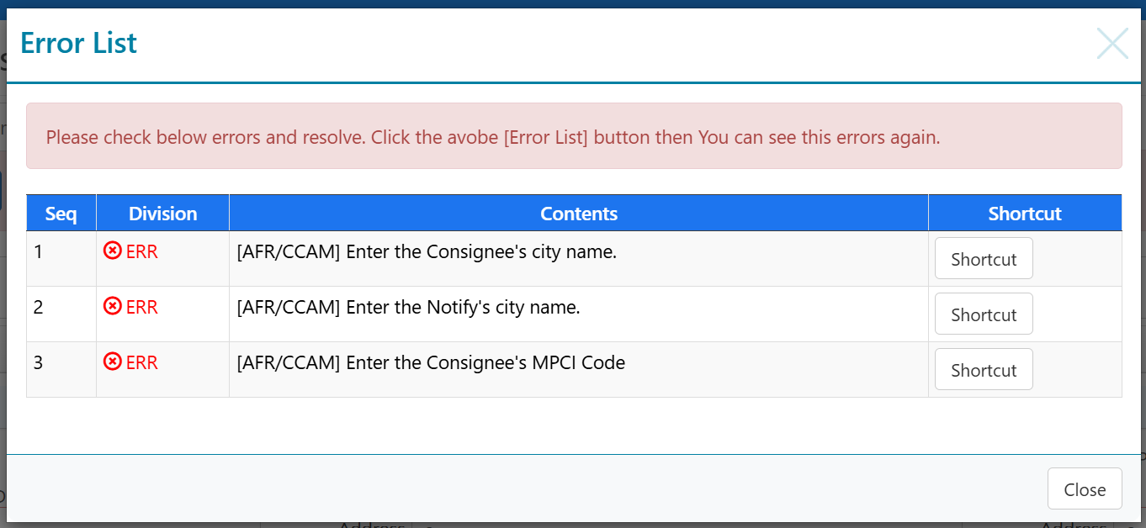
Warning when Consignee/Notify City name or Consignee MPCI Code is missing.

2.5 Character-limit warning
The MPCI Code must not exceed 7 characters. A warning is shown if the entry is too long.
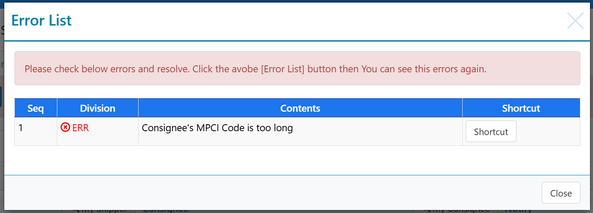
Warning: “Consignee’s MPCI Code is too long” (max 7 characters).

2.6 Export List submission
When submitting from the Export List screen, the same validations apply and the warning is shown in a pop-up window. The B/L cannot be submitted until all errors are resolved.
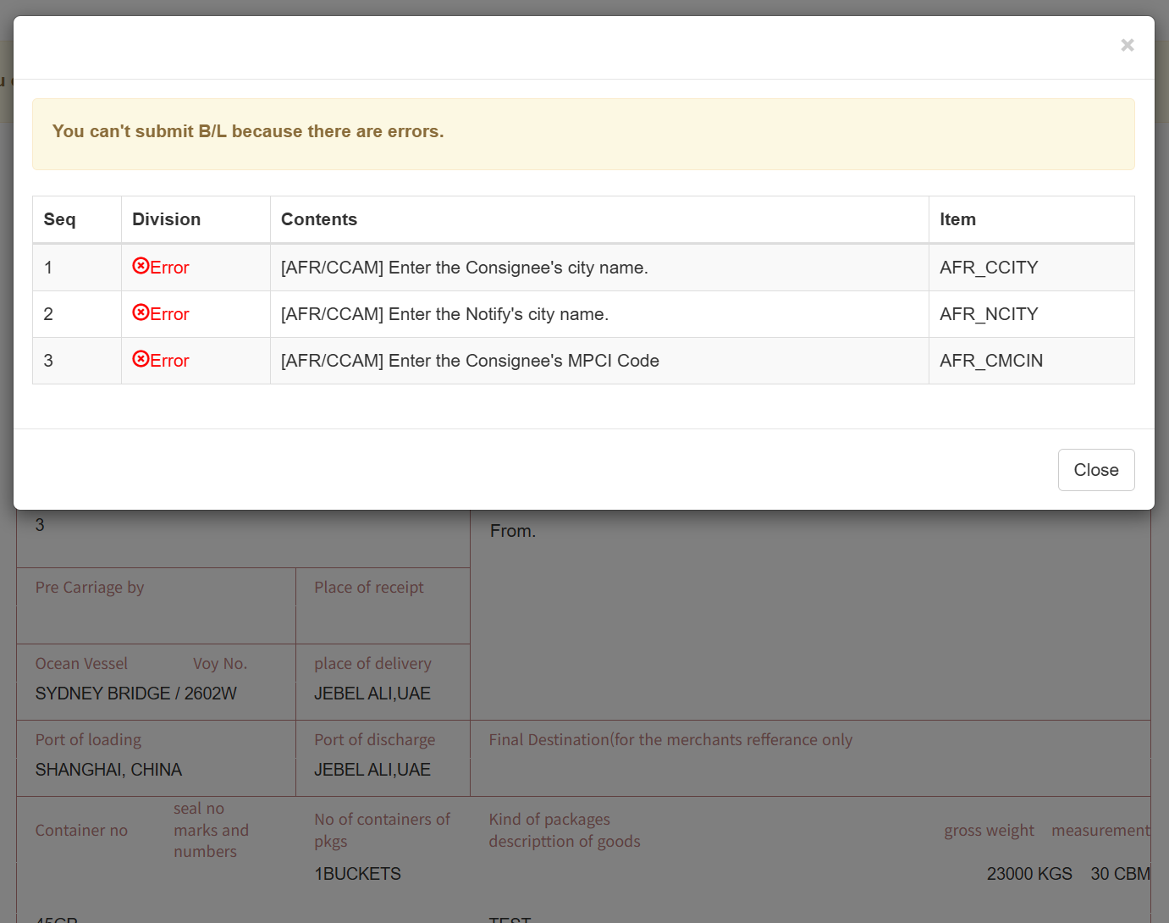
Export List submission blocked – item codes AFR_CCITY, AFR_NCITY, AFR_CMCIN.

3. B/L Management Portal
The internal portal (Shipping Management › B/L – B/L Management) has been updated on the AFR/CCAM Info and HS Code tabs to capture the same MPCI-mandatory data, with per-container HS Code support.

3.1 HS Code – per container (Tab 8)
- Enter the HS Code for each container on the “8. HS Code” tab and save via Save HS.
- In e-Service only one HS Code value can be entered per B/L. When a different HS Code must be applied per container, use Tab 8 in the portal.
- HS Code requires a minimum of 6 digits; for export cargo, use the UAE Customs classification.
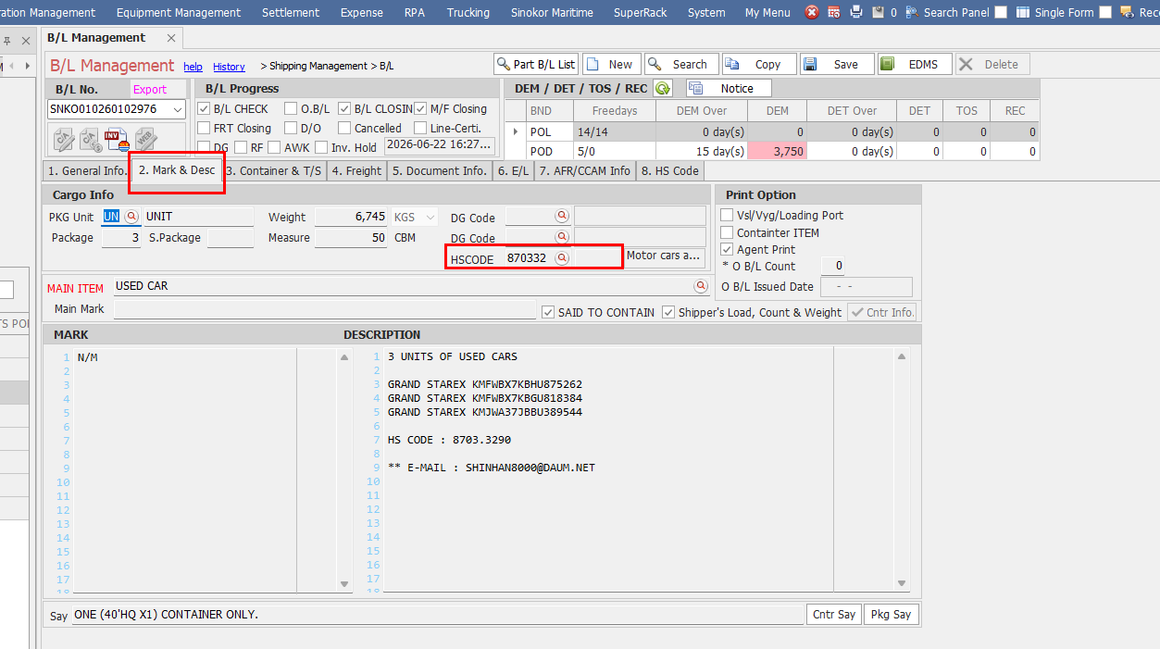
Tab 2 (Mark & Desc) shows the single HS Code field; per-container HS Codes are entered in Tab 8.
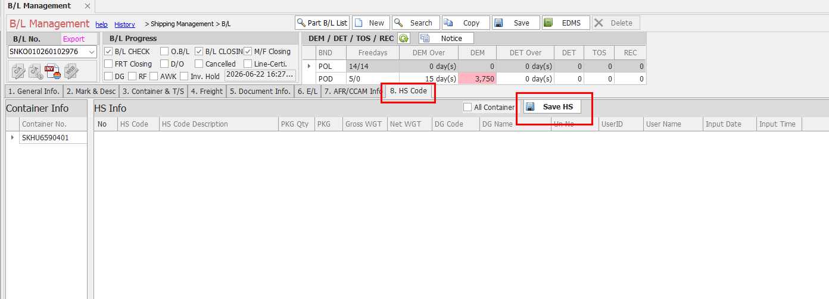
Tab 8 – HS Code: per-container HS info entry with the Save HS button.

3.2 AFR & CCAM mandatory fields (Tab 7)
On the “7. AFR/CCAM Info” tab, the fields highlighted in red are mandatory:
- Consignee: Nation, Reg No. Type, Company Reg No., City Name, MPCI Code.
- Notify: Nation, City Name.
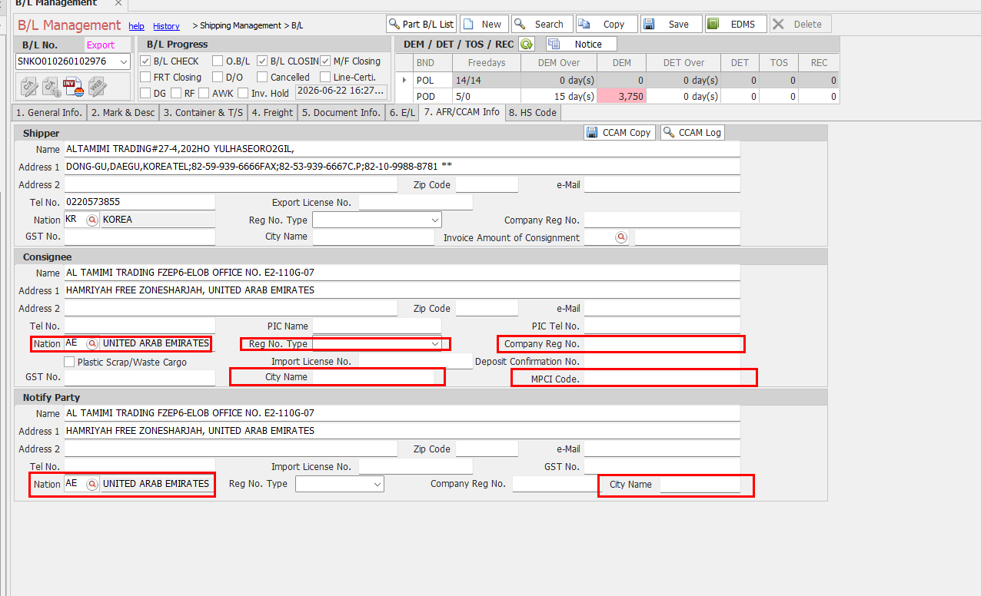
Tab 7 – AFR/CCAM Info: mandatory Consignee and Notify fields (red boxes).

4. Action Points
- In e-Service, set Cargo Type = Consol (House B/L) for consolidated cargo so the MPCI Code field appears, and collect the forwarder’s MPCI code in advance.
- Always capture Consignee/Notify Nation and City Name, and the MPCI Code for CONSOL (House B/L) shipments.
- Keep the MPCI Code within 7 characters; it is the forwarder’s UAE MPCI Party ID.
- Use Tab 8 (HS Code) in the portal when containers carry different HS Codes.
- Resolve all BL CHECK warnings now — they will become blocking errors.

